Follow this link to complete the Case Study: Click here (Links to an external site.)
Note: If the above link does not work, open a new browser page, then copy and paste the following: www.. /~ecet/ecet493/assets/flash/mod03/mod03.html
Let me know as soon as possible if you have any trouble with the link.
In a word document, Discuss the module 3 case study from the perspective of professional responsibility and the role of a whistleblower.
When you are done, submit your well formatted word document here.
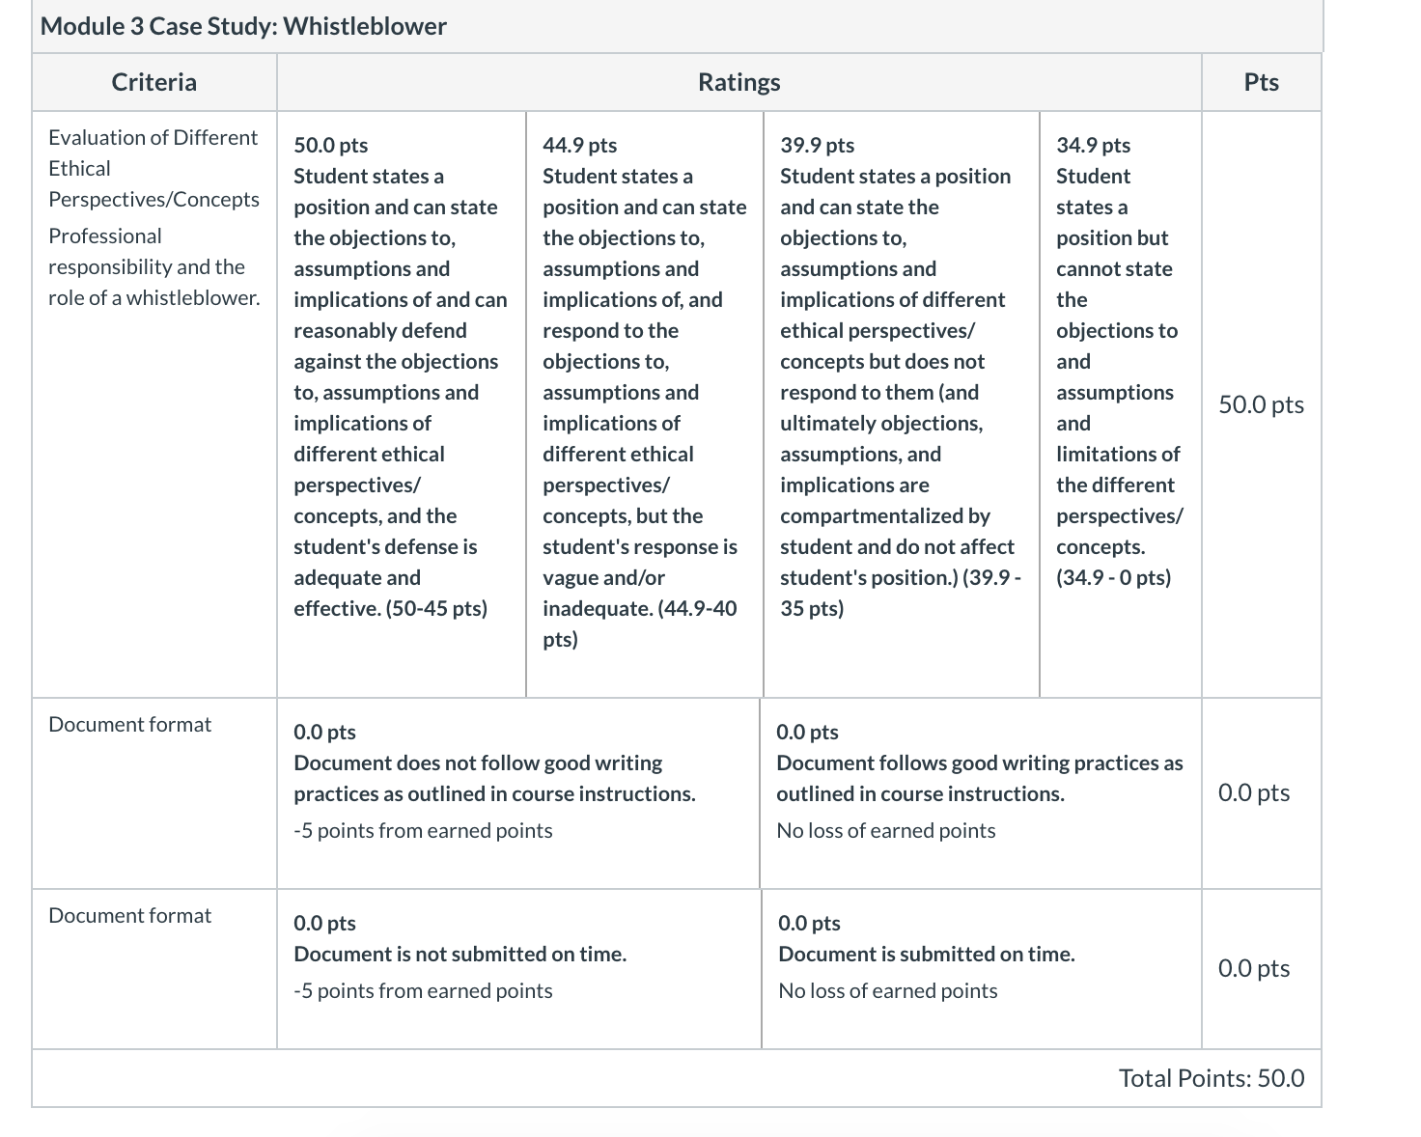

I have a scenario right here I already answered all the questions please follow the and write about it

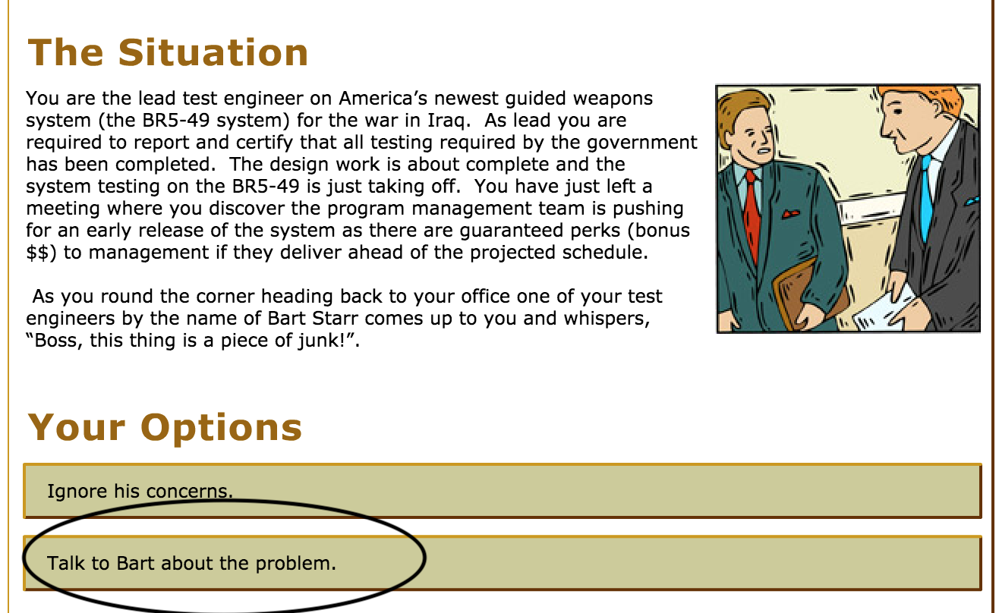

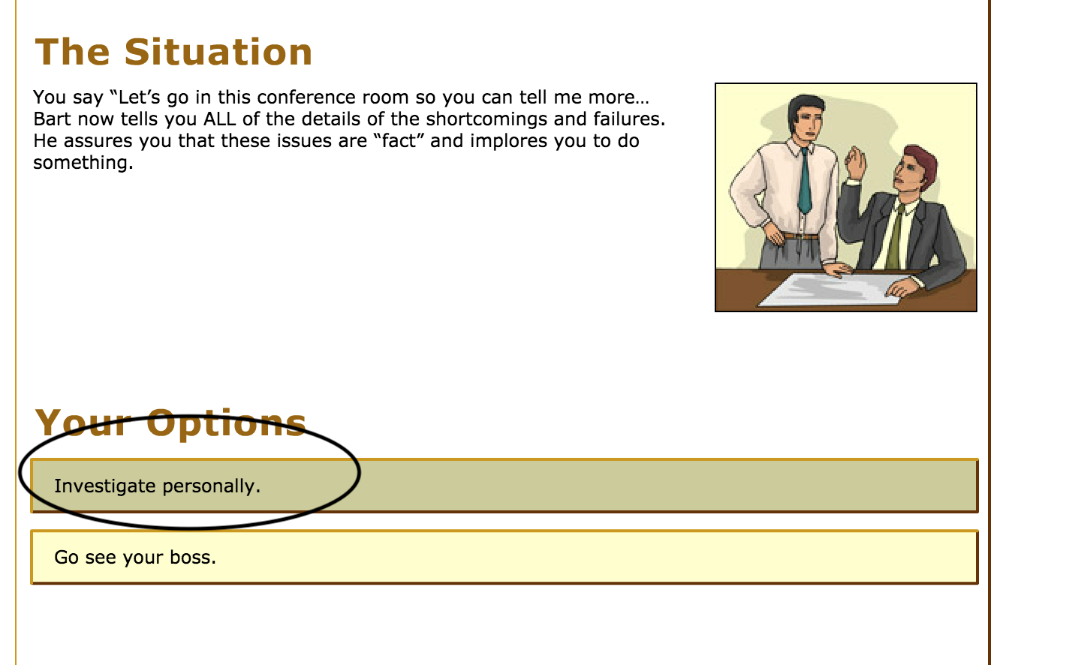

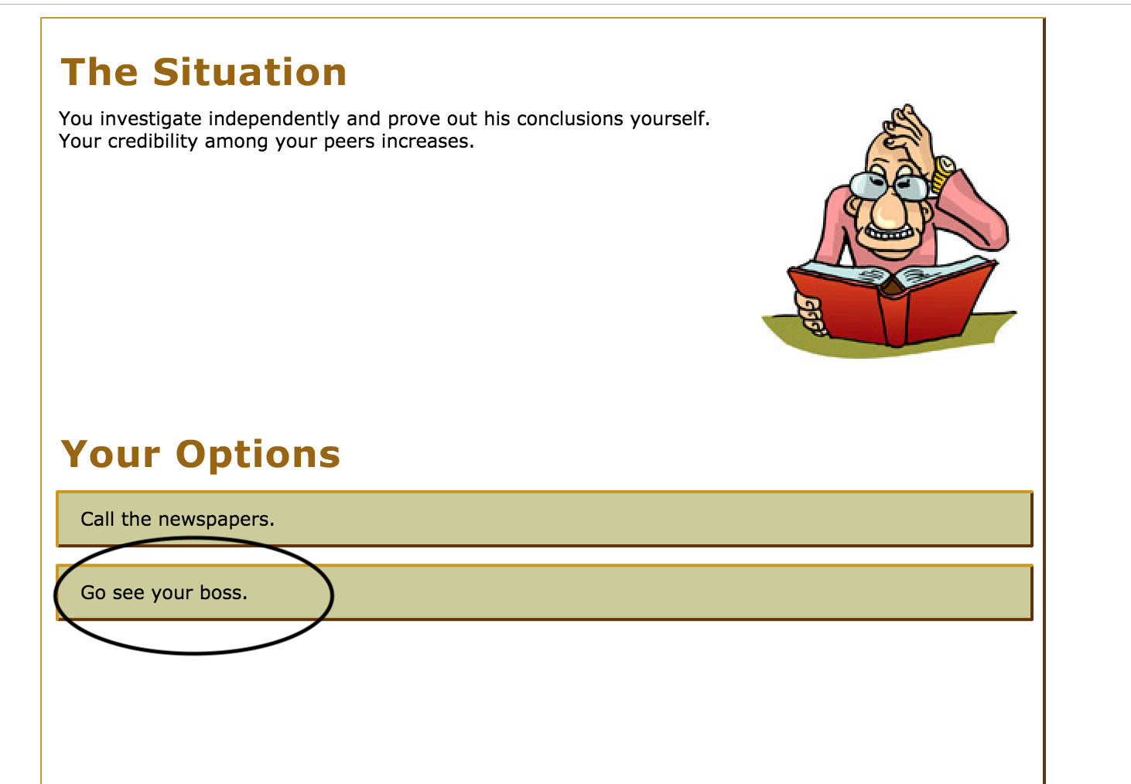

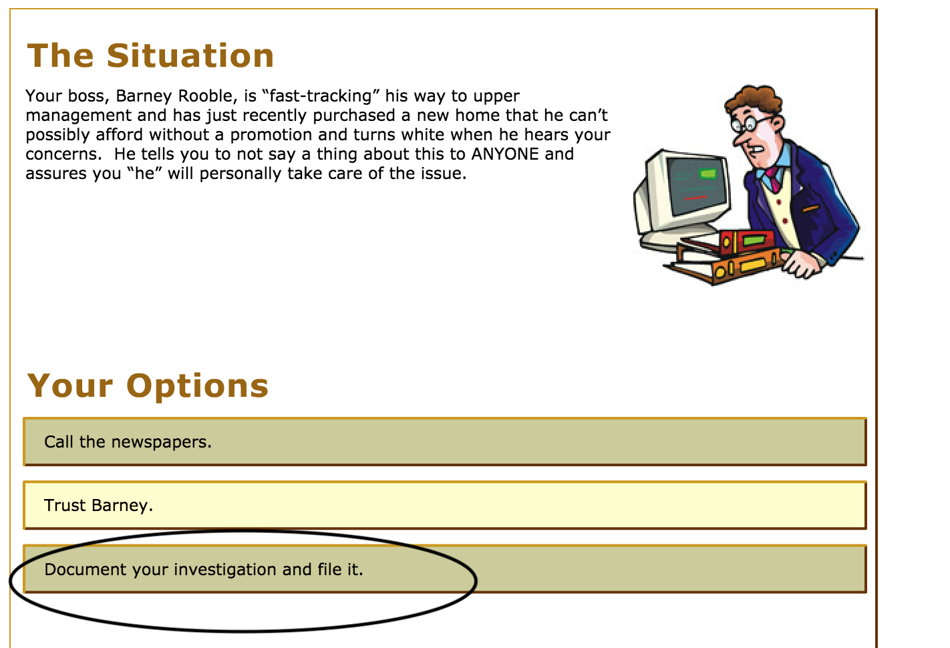

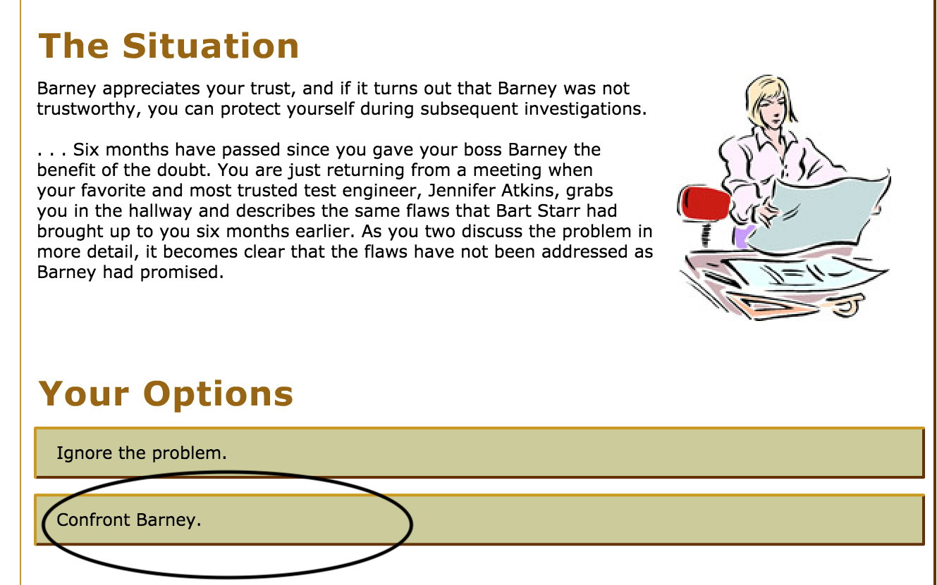

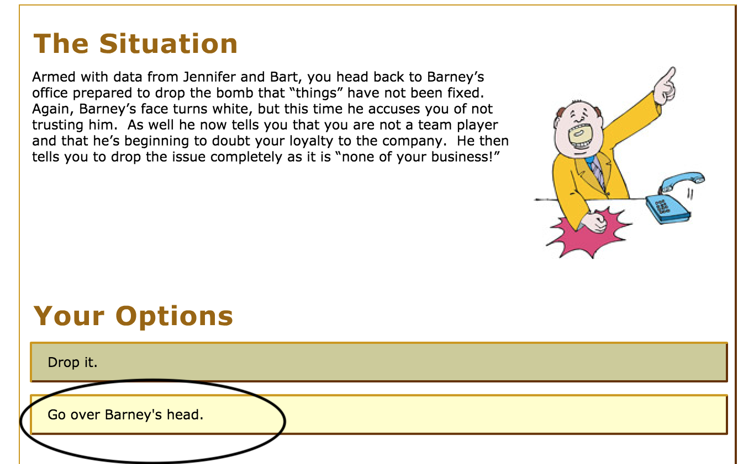

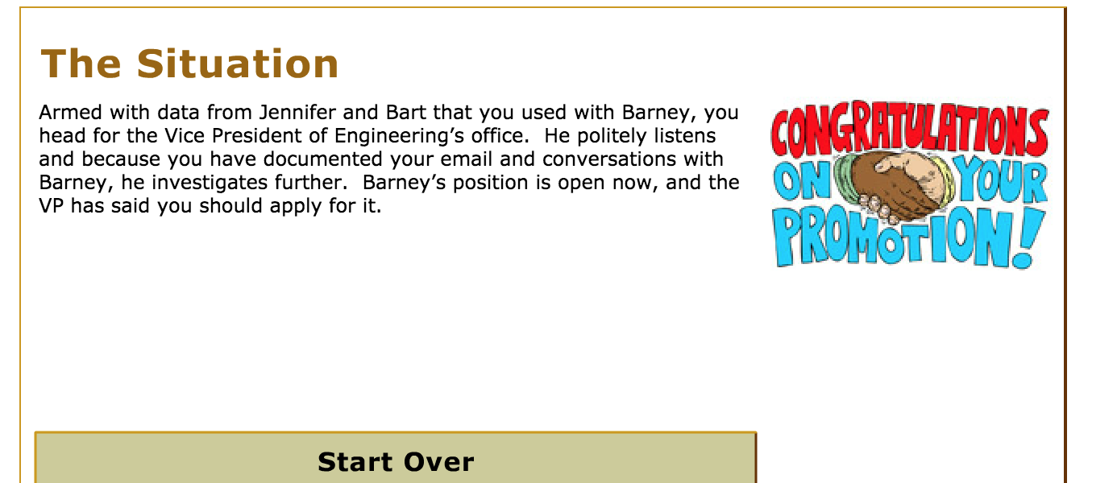

- Talk to Bart about the problem

- Investigate personally

- Go see your boss

- Document your investigations and file it

- Confront Barney

- Go over Barney’s head

